DOKUZ EYLUL UNIVERSITY

Faculty of Engineering

Electrical and Electronics Engineering

**EED 1005 Introduction to Programming Preliminary#4**

Student Name : Yavuz BALI Number:2014502021

**Task 1:**

#include<stdlib.h>

#include<stdio.h>

int main()

{

printf("*********\n*\t*\n*\t*\n*********");

return 0; }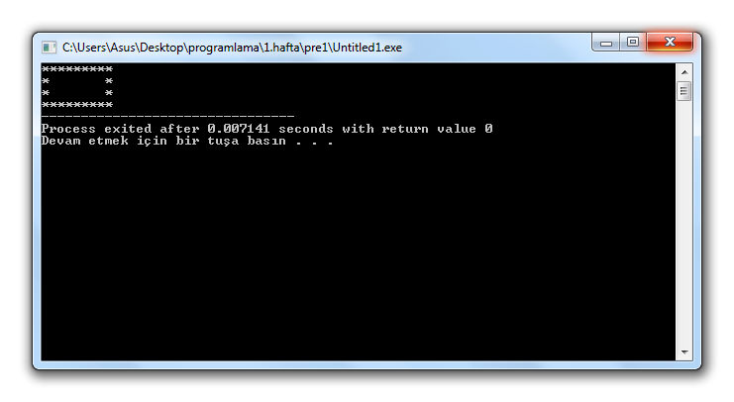

**Task 2 :**

#include<stdlib.h>

#include<stdio.h>

int main()

{

float y,x;

printf("Please enter x value :"); scanf("%f",&x);

y=3/(5*x*x*x-3*x*x+7*x-2);

printf("y is equal to :%.3f",y);

return 0;

}